Sunshine and Rainbows

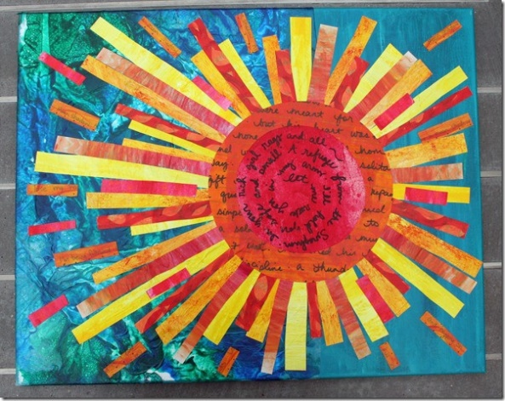
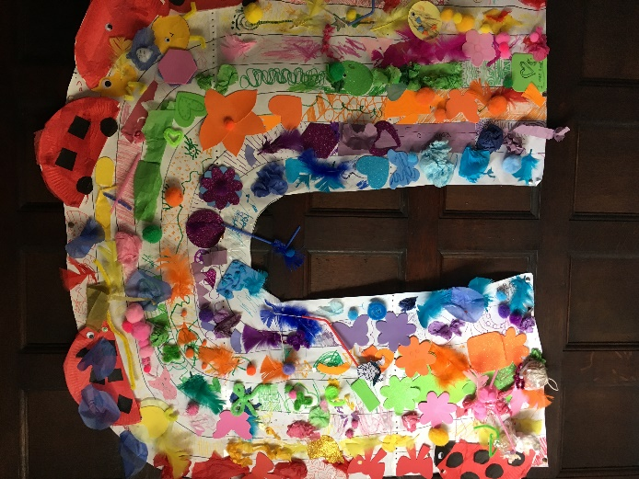
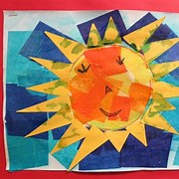

You will need:
- lots of brightly coloured paper in different textures
- PVA glue or glue sticks
These could be made individually or ask a group to create a big rainbow or sunshine.

