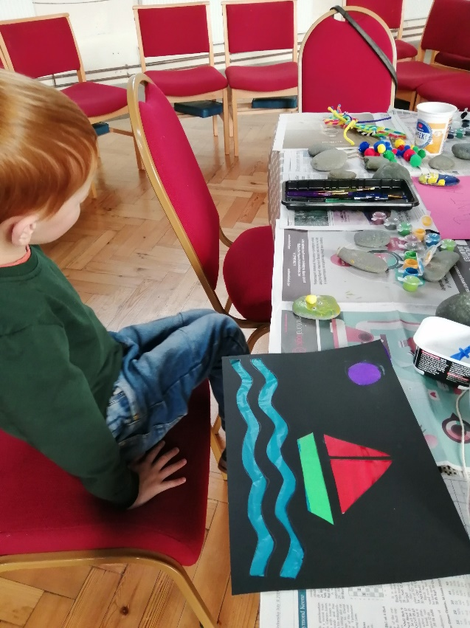**Stained Glass Windows**

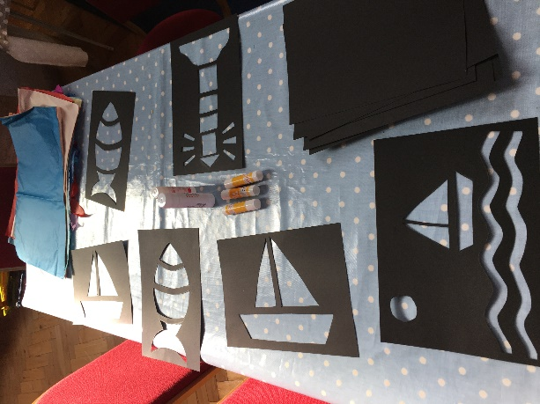You will need:

Black A4 card or sugar paper

Craft knife (for adult use)

Various colours of tissue paper

Glue sticks

Scissors

Draw the shapes using pencil onto black paper. Cut out carefully. This will need an adult because it requires a craft knife. (We got some of these ready in advance). The children then choose what colours they want to fill in the gaps with and cut their tissue paper to the right shapes. Then they stick them on the back using glue.

Or you can cut lots of small squares of tissue paper and children choose what colours they want to fill in the spaces. This can match your theme for the day: eg seaside, Jesus, light, creation.

