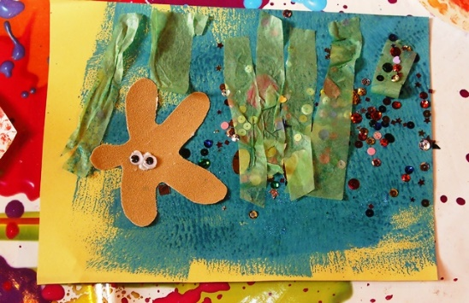
Sea Collage
You will need:
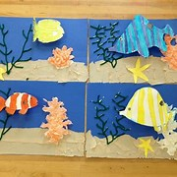
Sand
Shells
Dried seaweed
Craft papers
Paints
Sequins/beads

Give ideas for creating a sea collage, but let children do their own. Painting the background first is a good idea, then glue the different materials on top. You can’t go wrong!

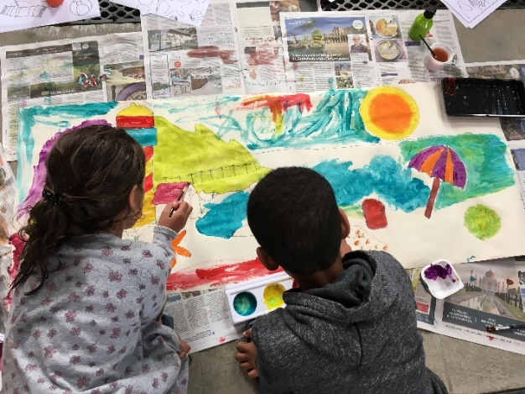
Sea or Beach Painting
You will need:
Large paper (we used wallpaper)
Pencils
Poster paints
Mixing pallets
Ask children for ideas - what do we find at the beach? Draw rough outlines of beach, sea, bucket, spade, lighthouse, beach ball etc. Children can choose a bit to paint. This worked well as a collaborative project and the end result was very good.

Sea Painting – wax relief
You will need:
Wax crayons
Paints and mixing pallets
Use a large sheet of paper (wallpaper/A3). Draw the underwater creatures, fish, shells, seaweed etc in wax crayon. Then paint over with watery wash of paint. The creatures will stand out clearly (by magic!)

