Scavenger Hunt in a churchyard.
You will need a partner and a bag to collect objects.
Work with a partner to find all these things. Collect them and put them in the bag. Get ready to share your treasures at the end and there will be prizes for the most unusual things. Good luck with the challenge!
Be careful not to trample over graves, but walk sensibly between them.

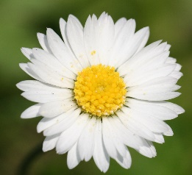
- Something soft
- Something spiky
- Three different shaped leaves
- Something round
- A stone
- A smooth stick
- Something yellow
- Something blue
- An insect
- A feather
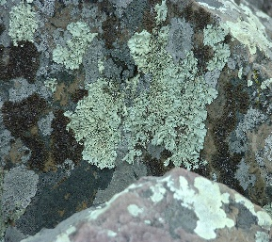
- Some lichen or moss
- A white flower
- Something fluffy
- An item which is made of many parts
- Something unusual (which nobody else will find)

