Recipe ideas for Come Rain or Shine 2020

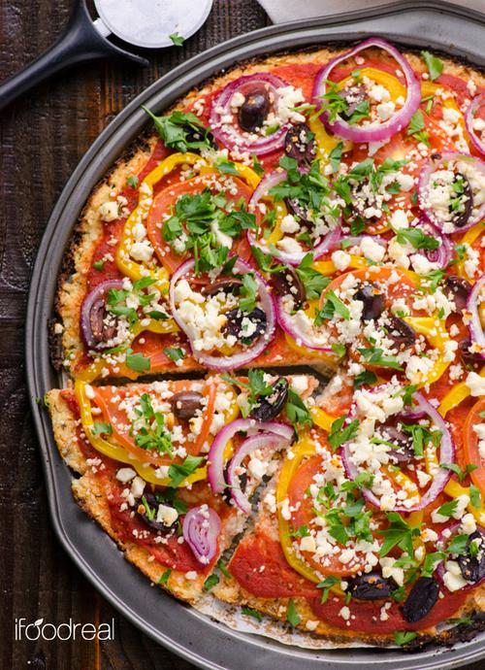
Mini pizzas.
Ingredients:
Pizza bases, enough for 1 each.
Tomato pizza sauce
Variety of toppings: Grated cheese, mushrooms, peppers (different colours), sweetcorn, tomatoes, red onions.
You can also add tuna, cooked bacon or pepperoni.
Children can choose toppings, make their own pizzas and cook them.
These can also be made on toasted hamburger rolls, split in half.

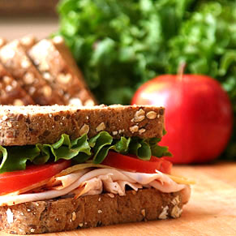
Healthy Sandwiches.
Ingredients:
Sliced wholemeal bread (Tesco = 59p)
Sliced 50/50 bread (Kingsmill = £1.10)
Buttery spread
A variety of fillings: ham, grated cheese, tuna, hard boiled eggs, lettuce, cucumber, tomatoes, sweetcorn, mayonnaise, pickle.
Children help to prepare fillings – eg mix tuna and mayonnaise, chop cucumber and tomatoes (if supervised). Then they can choose their own fillings and make a sandwich to eat.
Alternatively, prepare fillings as above and make wraps with soft tortillas.

Easy Pasta Bake: serves 6.
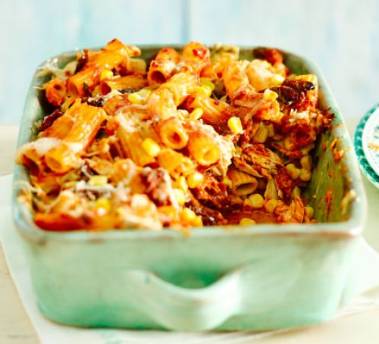
500g short pasta (twists, tubes etc)
2 x 400g cans of chopped tomatoes
300ml double cream
3 x 120g cans tuna in brine (drained)
198g can of sweetcorn
Chopped peppers, mushrooms, onions (optional)
100g grated cheese
Cook the pasta according to packet instructions. Heat grill. Meanwhile cook tomatoes in a saucepan with salt and pepper. Add cream, simmer and stir for 5 minutes. When cooked, drain pasta and add to sauce. Then stir in tuna, sweetcorn and chopped vegetables, if using. Pour into ovenproof dish and scatter cheese on top. Place under medium/hot grill for 5 – 10 minutes until golden and bubbling on top.
This recipe can easily be adapted by adding different vegetables or swapping tuna for chopped ham.

Sausage Casserole: serves 6
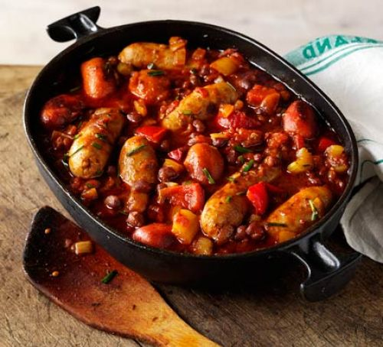
1 large onion, chopped
1 red pepper, chopped into chunky pieces
2 carrots, sliced
12 chipolata sausages
2 x 400g cans chopped tomatoes
Chicken or vegetable stock cube
1 can aduki beans or mixed beans
Heat oven to 180 degrees C/ 160 fan oven/ gas mark 4.
Cook the chopped onion in a heavy based, oven proof casserole in oil for 5 mins until softened. Add carrots, red pepper and sausages. Continue to stir and cook until sausages are turning brown. Stir in tomatoes and stock cube. Season with salt and pepper and bring to the boil. Place in oven and cook for 30 minutes. Stir in the beans and return to oven for 10 mins or until sausages are cooked through.
Serve with pasta, or chunky bread, and salad.

Easy Spaghetti Bolognese: serves 4 (or 6 children)
- 2 tbsp olive oil
- 400g/14oz beef mince
- 1 onion, diced
- 2 garlic cloves, chopped
- 100g/3½oz carrot, grated
- 2 x 400g tin chopped tomatoes
- 400ml/14fl oz stock (made from stock cube. Ideally beef, but any will do)
- 400g/14oz dried spaghetti
- salt and pepper
Method
- Heat a large saucepan over a medium heat. Add a tablespoon of olive oil and once hot add the beef mince and a pinch of salt and pepper. Cook the mince until well browned over a medium-high heat (be careful not to burn the mince. It just needs to be a dark brown colour). Once browned, transfer the mince to a bowl and set aside.
- Add another tablespoon of oil to the saucepan you browned the mince in and turn the heat to medium. Add the onions and a pinch of salt and fry gently for 5-6 minutes, or until softened and translucent. Add the garlic and cook for another 2 minutes. Add the grated carrot then pour the mince and any juices in the bowl back into the saucepan.
- Add the tomatoes to the pan and stir well to mix. Pour in the stock, bring to a simmer and then reduce the temperature to simmer gently for 45 minutes, or until the sauce is thick and rich. Taste and adjust the seasoning as necessary.
- When ready to cook the spaghetti, heat a large saucepan of water and add a pinch of salt. Cook according to the packet instructions. Once the spaghetti is cooked through, drain and add to the pan with the bolognese sauce. Mix well and serve.

Jacket Potatoes
These can be cooked at home, if necessary, and kept warm in an insulating bag or a slow cooker turned to low. Offer a variety of fillings such as:
Baked beans
Grated cheese
Coleslaw
Tuna mayo
Sweetcorn

Easy banana and blueberry muffins: makes 12
300g self-raising flour
1 teasp bicarbonate of soda
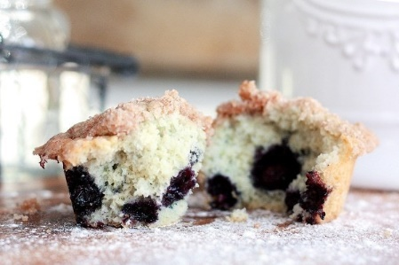
Pinch of salt
100g soft brown sugar
50g porridge oats plus 1 tabs for topping
2 medium bananas (as ripe as possible)
2 tabs plain yoghurt
4 tabs vegetable oil
1 egg
150g punnet of blueberries
Heat oven to 180 degrees C /160 fan oven/ gas mark 4. Line a 12 hole muffin tin with cake cases.
Sift flour, bicarb and salt into a large bowl. Stir in sugar and 50g oats. On a plate, mash bananas with a fork. In a small bowl, beat together egg, yoghurt and oil. Add this mixture and bananas to the flour mixture. Fold together gently until almost combined. Then add the blueberries and stir in gently.
Spoon the mixture into the 12 muffin cases and sprinkle the tops with remaining oats. Place in oven and cook for 18-20 mins until risen and golden brown on top. Leave in tin for 5 mins, then lift out onto a wire rack to cool. Eat warm or cold.

Fruit salad.
Chop a selection of fresh fruit in rainbow colours and place in a bowl. Choose from pineapple, apples, grapes, kiwi, strawberries, oranges/satsumas, melon. Children can help with this, if supervised when using knives.

Fruit kebabs.
See above for fruits. Chop to similar sizes and thread onto wooden skewers. These can be dipped in melted chocolate for a delicious (but still healthy) treat.

Fruit smoothies.
You will need a smoothie maker or liquidiser for this. Experiment with different juices and soft fruits.
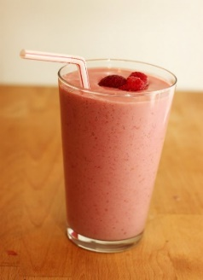
Choose from:
- Apple juice, banana, strawberries.
- Pineapple juice, mango, banana, melon.
- Apple juice, blueberries, strawberries.
- Or make up your own favourites.

