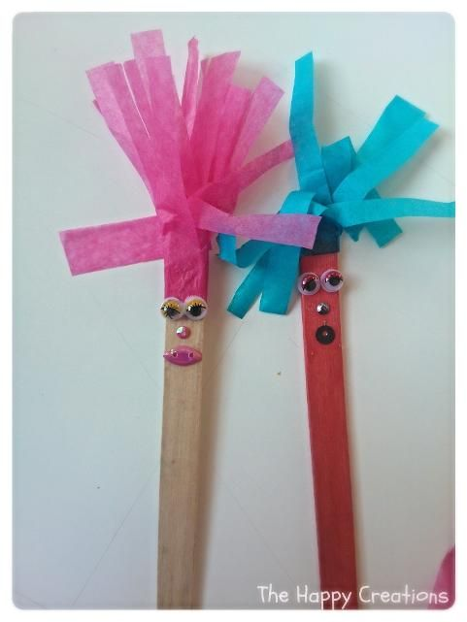
Puppet making
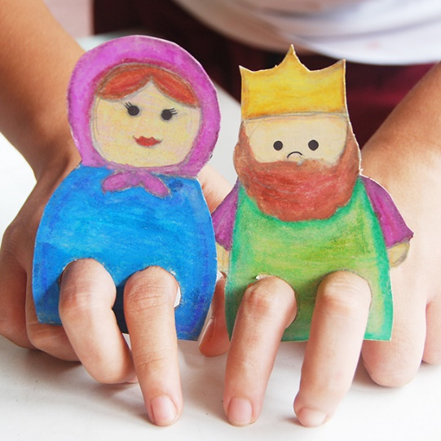

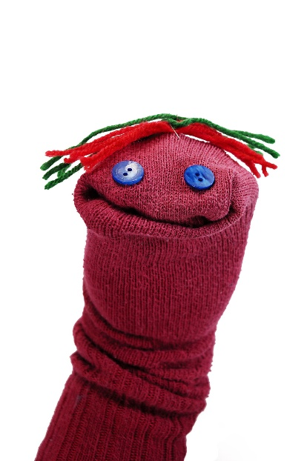
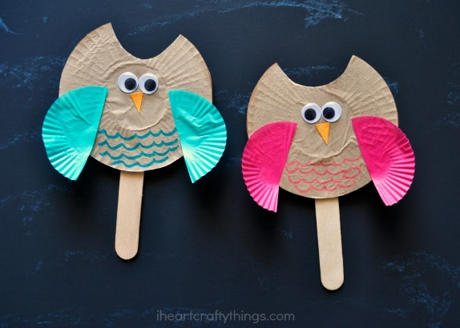

These can be made in lots of ways:
- Use painted card and cut holes for fingers
- Use lolly sticks and decorate as characters
- Sew old buttons onto a sock and add wool hair
- Use lolly sticks and paper plates to create creatures.
All of these puppet ideas can be linked with creation, stories, pirates, sea and sky themes. Encourage the children to use their puppets to tell stories.

