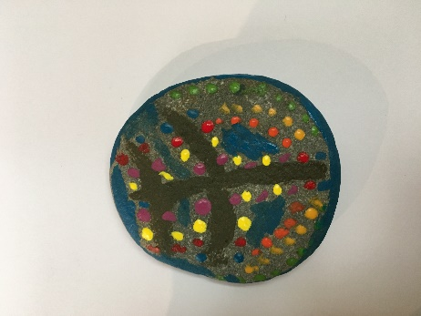
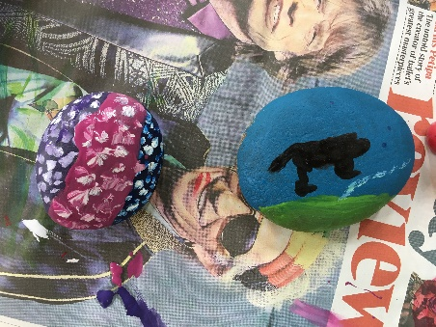
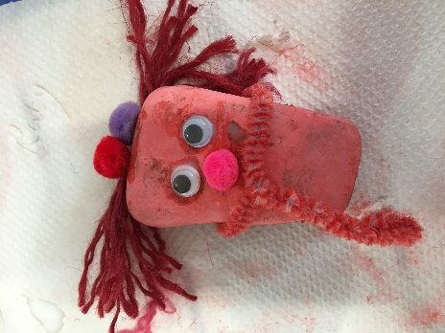
Pebble Painting
You will need:
Some smooth pebbles from the beach or interesting shaped rocks
Acrylic paints
Brushes
Pipe cleaners/wool for hair
Googly eyes
Aprons, or old shirts.
Let the children choose a pebble and decide what to paint. This could be an animal, cartoon character, mythical creature or anything. This could be linked to a story you have told (St Petroc and the dragon, Peter the fisherman, Noah’s ark). Acrylic paints don’t wash out, so beware!
Encourage children to make up a story using their painted pebbles.

