Lolly stick crafts.
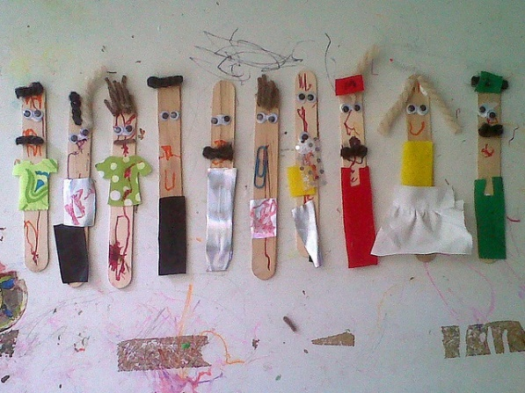
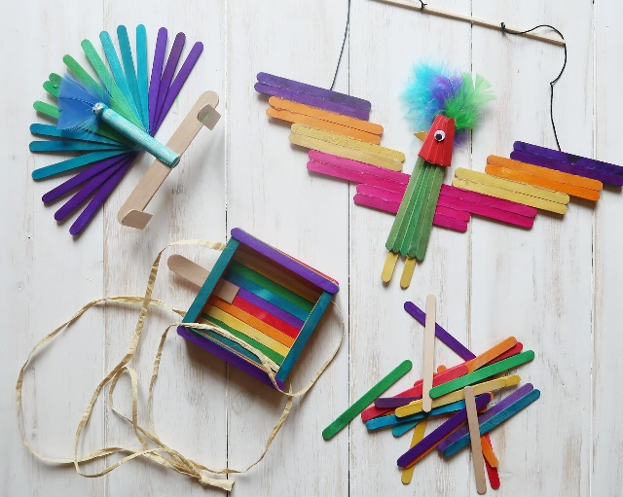
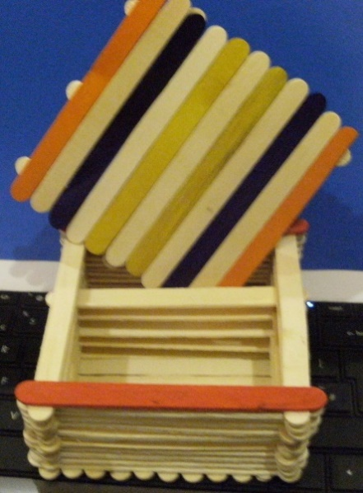
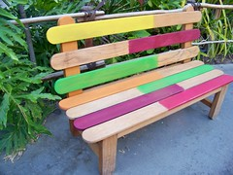

You can buy unpainted lolly sticks fairly cheaply (£1.90 for 100 at Amazon)
You will also need: paints, felt pens, PVA glue, googly eyes, scraps of fabric.

This can fit in with several themes: Creation, animals, pirates (treasure box), story-telling, sea and sky.
Or allow the children to be creative and make anything they want.

