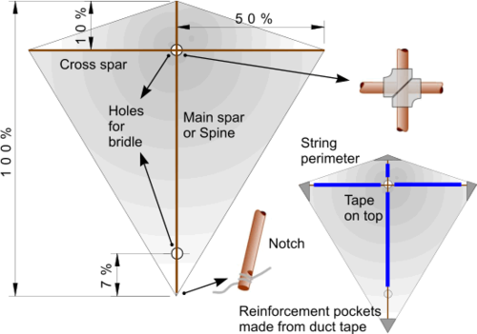
Kite making.

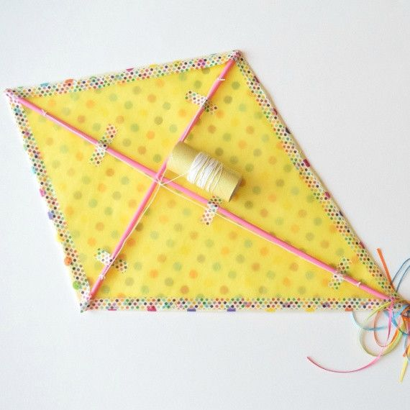

You will need:
Green garden canes
Masking tape
Thin fabric, or paper
String for a tail
Cut the canes carefully (adults only). Cut the fabric or paper using a template. Reinforce the corners with masking tape. Bind the 2 sticks together at intersection with masking tape. Fit the canes into the masking tape pockets at each corner. Decorate your kite with patterns and create a tail to help it fly. (This is quite labour intensive, so you will need adults to supervise).

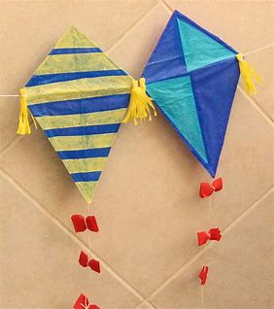
An easier version for smaller children:
These are made from paper drinking straws and tissue paper.

