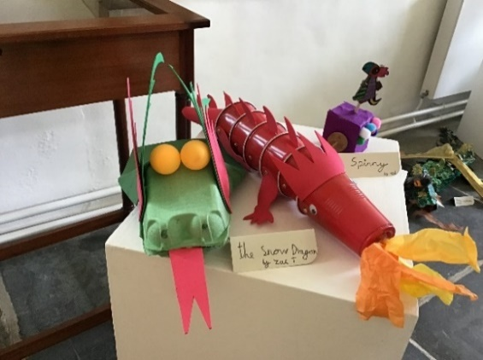
Junk Modelling
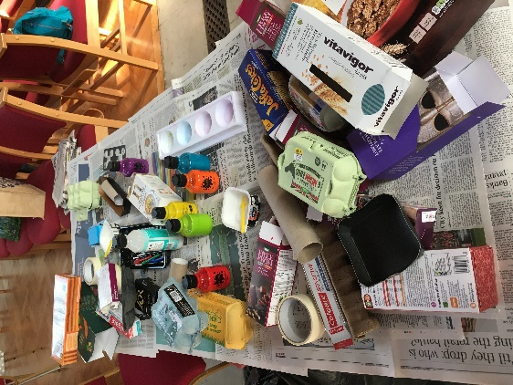
You will need:
Different sized boxes, tubes, interesting cardboard, egg boxes, paper cups etc
PVA glue
Masking tape
Poster paints

Everybody loves junk modelling. You can leave it completely up to the children to decide what to make or you can link it in with your focus for the day: eg Cornish dragons, animals, sea creatures. Encourage children to make up a story about their model to tell a friend at the end.

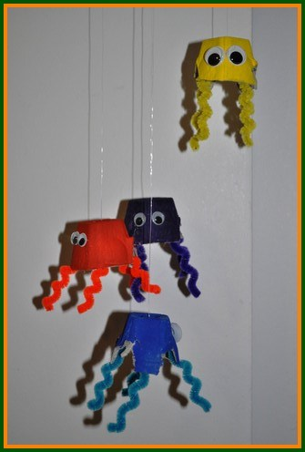
Mobiles.
You can also use junk to make hanging mobiles. For this one you will need egg boxes, pipe cleaners, thread or fishing line, googly eyes and paints.

This idea could be adapted for lots of other themes: fish, butterflies, hot air balloons, birds, bees …..

