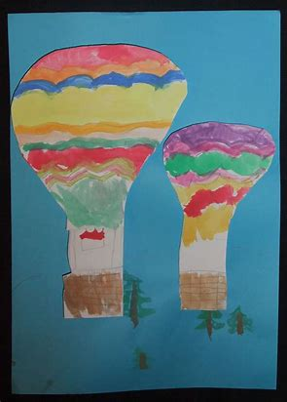
Hot air Balloons
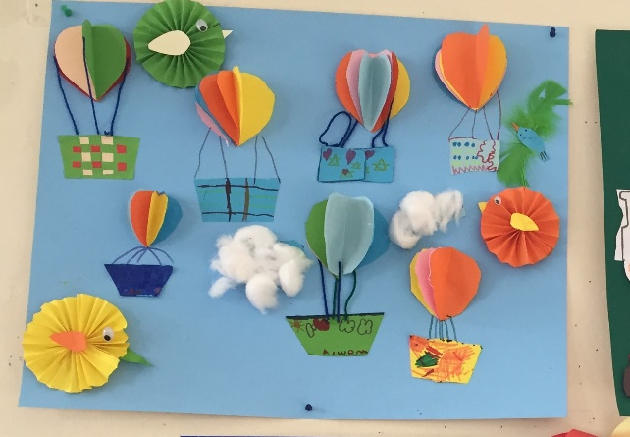

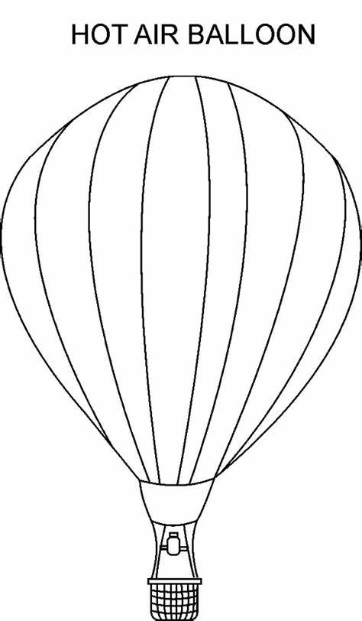

You could make collage balloons to stick onto a sky background, adding 3D bits or woven paper baskets. Or you can use paint to decorate a balloon. Give children an outline and a collection of different materials to choose from and ask them to come up with a design. They will look fantastic altogether in a display.
