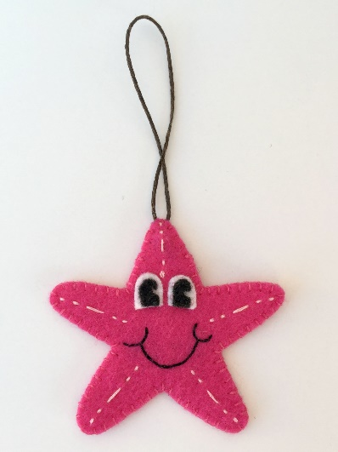
Hanging Ornaments:
These are lovely for children to make, but be aware that they will need lots of support (perhaps 1 adult to 2 children)
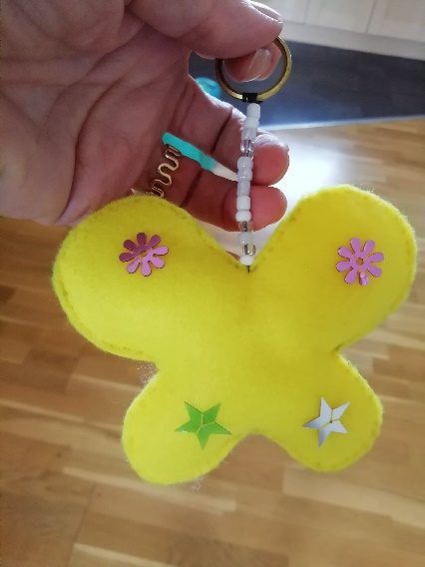
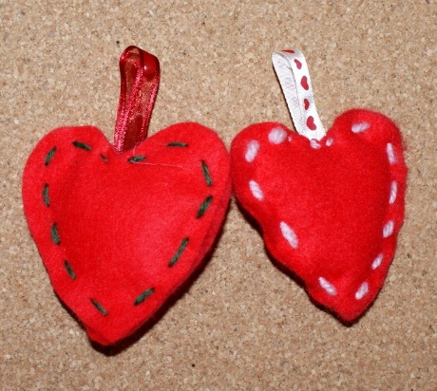

You will need:
Coloured felt
Embroidery threads
Ribbon for hanging
Large needles
Toy stuffing
Beads, buttons, sequins to decorate.

Cut out 2 shapes for younger children or allow older children to use a paper pattern to pin on and cut around. Children will need an adult to start them off with over stitching round edges. Leave a hole for stuffing. Then close up the hole with stitches. Decorate the outside with buttons or sequins. These can be glued with fabric glue or sewn in place.
This will work well with creation, sky and story themes.

