Five things editors forget on ACNY
With more than 10 million page views a year and 85 per cent of visitors going to the site for the first time, A Church Near You offers a unique evangelism opportunity for Church of England churches, and sits at the heart of our national campaigns.
More than 88 per cent of editors would recommend the site to another church, our recent editor survey shows, but how can you get the most from the site? Here are five things that are easy to forget, but will help maximise your reach on A Church Near You.

The welcome
Just like in your church itself, the welcome on you’re A Church Near You page is the first contact a visitor will have with your church – and it can either make them want to go in further or turn away and leave. On our recent editor survey, a number of ACNY editors told us that visitors to their services or events have commented that the welcome on their ACNY page encouraged them to come along. One said: “We have a comment in our visitor book that says they visited our church purely because of the warm welcome felt on ACNY.”
Remember, you might be talking to someone who has never stepped foot in a church before. How can you make them feel as though your church might be somewhere they would feel comfortable? You could give visitors an idea of who goes to your church, so they know whether they’d fit in. Could you explain what happens when you meet on a Sunday, or what events or services are available throughout the week? Are you a quiet, reflective group? Is there a worship band or lots of activities for children?
Your building might be a tourist attraction or have an interesting story about when or why it was built. Visitors might be interested in hearing stories about the bricks or the architect, but make sure you start with information about your church community today. It might be better to give information about your building on a Page rather than in your welcome message. Find out how to add a Page here.
Churches should also include safeguarding information on their homepage. This could be one sentence at the bottom of the welcome message, saying: “For safeguarding enquiries about our parish, please contact us via our contact form on A Church Near You.”
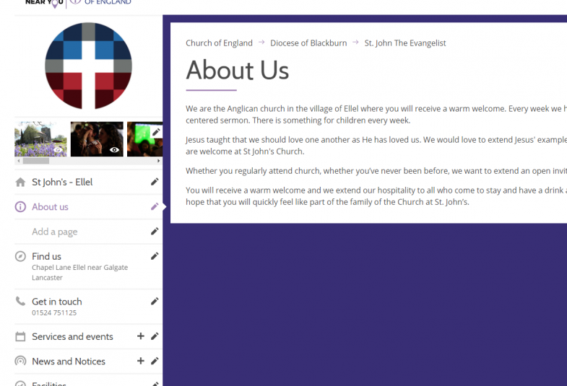

Gallery
A photo speaks a thousand words, and churches can now add up to 20 photographs on their Gallery. These should show the life of your church – from images of your worship to social events and the activities you run in the week.
Remember to show the full diversity of your church, in terms of gender, race, ethnicity, age and physical ability, for example. Also, think about the time of year. Perhaps remove your images from Christmas as we go into Lent, and think about adding pictures of your holiday club from last year as we head towards the summer.
You can also add a caption to these images. It’s important to do this for accessibility reasons.
We have set a limit of 20 photos to ensure that just the most up-to-date images are displayed on ACNY. Photographs can look dated very quickly, so setting a limit encourages editors to change these images frequently.
Find out how to add your gallery here.
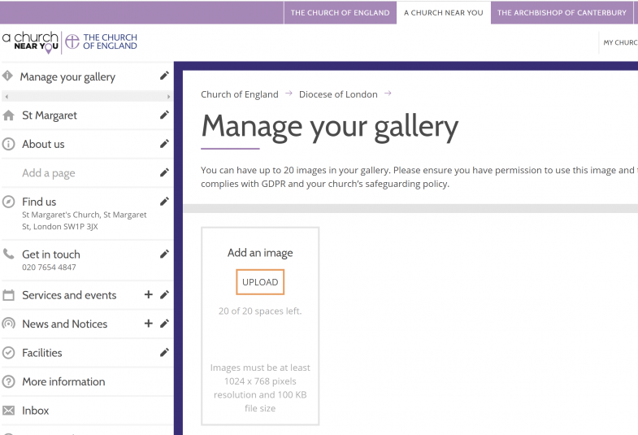

Cover picture
As with Facebook and Twitter, you can add a cover picture to your A Church Near You page. This will be one of the first things visitors will see when they land on your ACNY page – what would you like this image to communicate?
It might be tempting to use this space for a beautiful picture of your church building, however, it’s better to use this as an opportunity to show what your community is like. An image from a busy church service would work well, or perhaps a group shot from a social event. Do ensure that you have the correct permissions to share this image, and that it has been taken in line with your safeguarding policy.
Find out how to add a cover picture here.
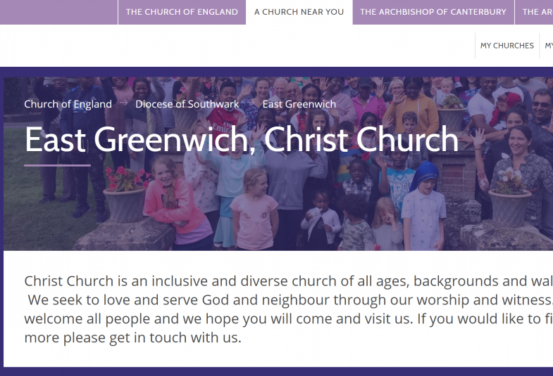

Getting here
In our digital age, people are used to be being able to find out the information they need in a few clicks. If they can’t, they go elsewhere – perhaps to another church or event, or another way to spend their time.
The ‘Getting here’ information is a key page to work on. You could put information about local transport options, or where to park for visitors – particularly if you do not have a church car park. Some rural churches might be accessible via a footpath, or perhaps you have bike racks for those cycling to your services. The more information you can include, the easier it will be for visitors to plan.
Remember to consider accessibility in this section, as we do hear from wheelchair users of when this information has meant they were able to attend a church, and unfortunately also when this information has not been updated and their visit was negatively impacted through accessibility issues. For this reason, it is also vital that churches fill in the ‘Features and facilities’ tags – find out how to do that here.
If you don’t fill in this section, ACNY will use your ‘About us’ information to fill this space.
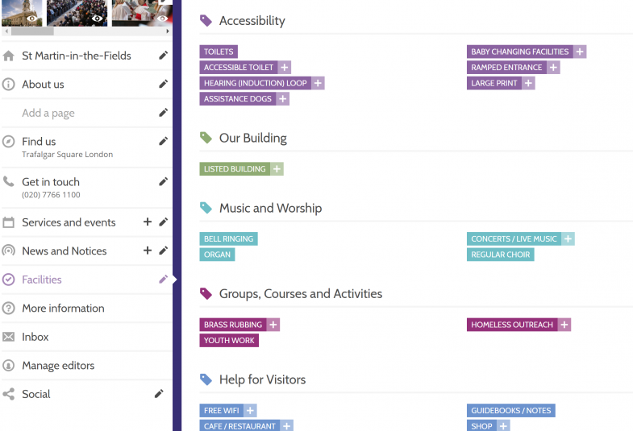

Use your ACNY page as your church website
Last year we made it possible for churches to use their ACNY pages as their church website by pointing the existing domain name to you’re A Church Near You. We built this functionality as 40 per cent of editors in our 2018 editor survey said they’d use ACNY as their website if possible. If these 40 per cent of editors did this, we estimated the Church of England could save more than £1 million in website hosting fees. How much could you save each year?
Many churches already use their AChurchNearYou profile as their main website to save money on redesigning their site, save money on their web hosting, and save money and mitigate risk securing their website.
Find out how to do the custom domain set-up here.
If your church has not yet claimed their A Church Near You page, find out how to become an editor here.
If there are any other features you need help with, do visit our Editor Help Centre, which has hundreds of blogs to help you use the site.

Amaris Cole, Digital Content and Communications Manager

