Cork Boats
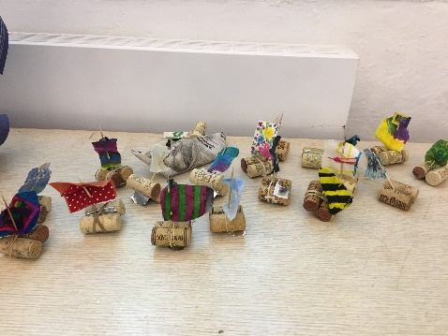
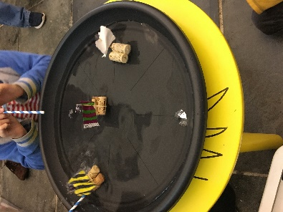
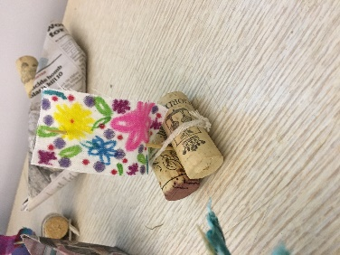

You will need:
2 corks for each boat
Cocktail sticks
Fabric
Felt pens
Rubber bands
A tray/bowl of water for sailing them.
Take 2 corks and tie them tightly together using a rubber band. Cut a fabric sail. You could decorate plain fabric with your own design using felt pens. Add the sail with a cocktail stick and push it firmly down between the corks. Now you have a boat. You can have races with your friends across a “pond” – maybe a tray or bowl of water. Use a straw to blow your boat. To improve your boat, you can add a tinfoil keel underneath (a U shaped piece which helps the boat to stay straight) Why not experiment with how to attach your keel?

Coracles
You can make these from clay or by weaving raffia strips. You could start with a question: How can I make this ball of clay float? Let the children come up with ideas of how to make clay float. You could try out the coracles with lego people. Or you could make your own people using card. This could illustrate a story about saints. You could add a sail to your coracle.

Paper boats.
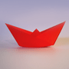
https://www.origami-fun.com/origami-boat.html
Use Origami instructions to make a paper boat. These can be decorated with felt pens. You could add a mast and sail if you like. Does it float? Can you race your friend’s boat across the bowl?

