Tree Collages
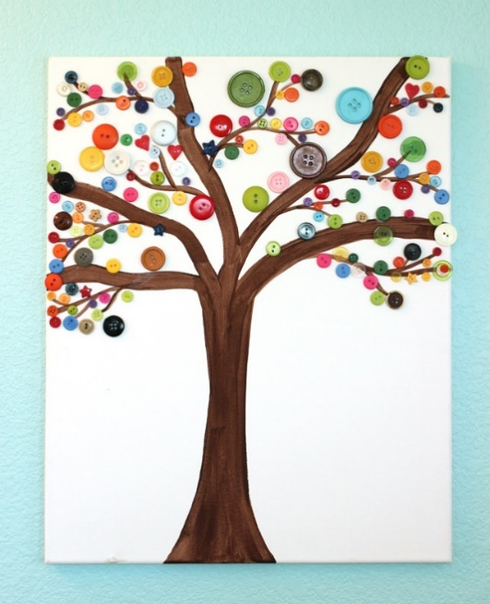
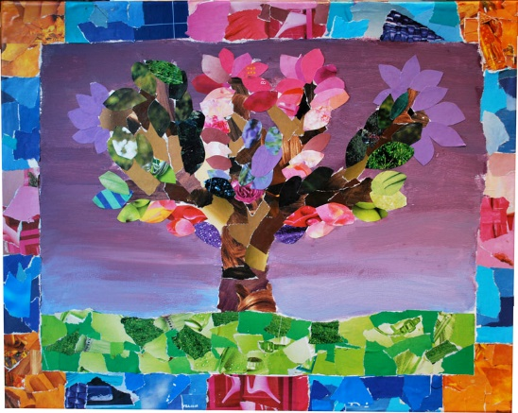

You will need:
A variety of papers, fabric strips, buttons, paints, PVA glue.
Here are a couple of ideas, but the possibilities are endless. This fits with creation theme. This might also link with outdoor work: bark rubbings, leaf pictures, outdoor art.

