Clay and Playdough
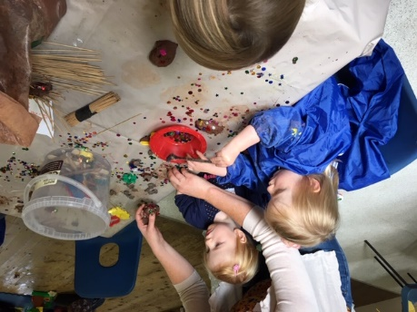
Children love to make things with clay. You can buy air dry clay fairly cheaply and there is no need to bake the models afterwards (Amazon has 12.5kg bag for £14.25). Link your clay models with any of the themes (sea, sky, stories, creation)
You will need to provide aprons for children.

Playdough is easy to make.

Playdough recipe | BBC Good Food
https://www.bbcgoodfood.com/howto/guide/playdough-recipe

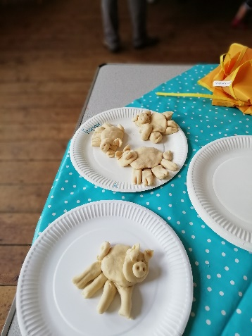
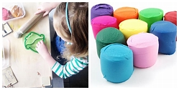

  - 8 tbsp plain flour.
  - 2 tbsp table salt.
  - 60ml warm water.
  - food colouring.

Again, you can easily link your playdough models with one of the themes.

